ZCU104/208 Eval Kit Notes

Development workflow:

Channel Sim SW design:
Transmit Module SW design:

Setup SW development computer:
- Computer with Ubuntu Linux version 20.04LTS
- Download and install Xilinx Petalinux version 2021.1
To fix the Kconfig issue during the petalinux-build command run “sudo apt- get install libncurses5”
- Download and install Xilinux Vitis version 2021.1
- Download ZCU208 BSP version 2021.1
- Download ZCU104 BSP version 2021.1
- Download and install Python
To install wxpython on Ubuntu, run these 2 commands:
sudo apt search python3-wx
sudo apt-get install python3-wxgtk4.0 python3-wxgtk-webview4.0 python3-wxgtk-media4.0
- Download and install gtkterm
Petalinux commands:

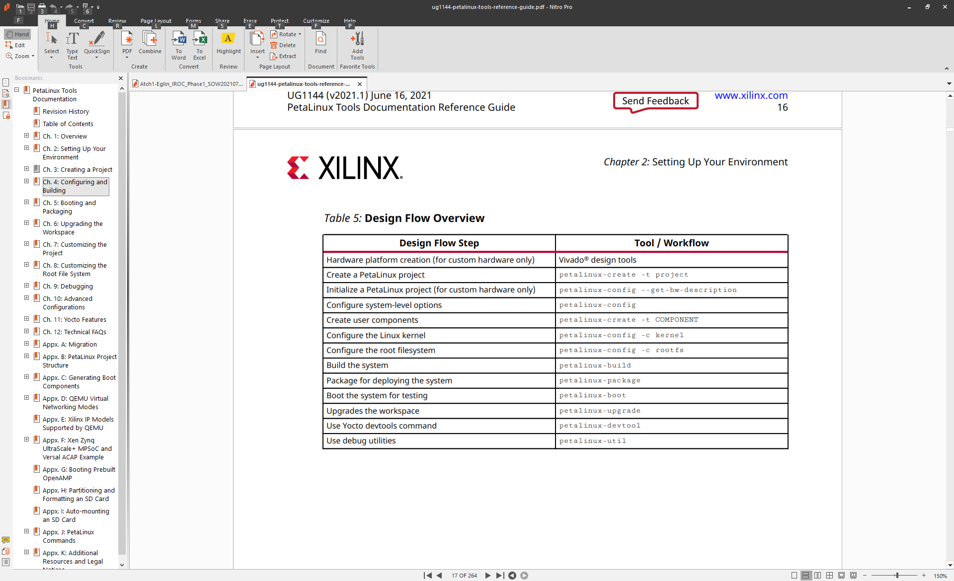

Steps to create a project from an existing BSP

Note: This procedures assume that Petalinux has been installed and all of the necessary Linux SW packages have been installed. Missing Linux SW packages will be prompted when running these petalinux commands

Source the shell:
source <folder were petalinux is install>/settings.sh
To use an existing BSP:
petalinux-create -t project -s <PATH_TO_PETALINUX_PROJECT_BSP>

To add HW configuration to the petalinux kernel project:
petalinux-config --get-hw-description <XSA file>
Note: If has error about Kconfig, install this package “sudo apt-get install libtinfo5”

Set status IP address, if needed. Only need to do this once
Subsystem AUTO Hardware Settings -->
Ethernet Settings -->
[ ] Obtain IP address automatically = N
(172.16.80.8) Static IP address (NEW)
(255.255.255.0) Static IP netmask (NEW)
(172.16.80.1) Static IP gateway (NEW)

Build the kernel
petalinux-build

Add python to kernel, if needed. Only need to do this once
petalinux-config -c rootfs
Filesystem Packages -> devel -> python -> python -> [*] python

Add ssh-scp to kernel, only need to do this once
petalinux-config -c rootfs
Filesystem Packages -> console -> network -> openssh -> [*] openssh-scp

Add libstdc++ to kernel, only need to do this once
petalinux-config -c rootfs
Filesystem Packages -> misc -> gcc-runtime -> [*] libstdc++

Add UIO Device Drivers
petalinux-config -c kernel
Device Drivers -> Userspace I/O drivers
- <*> Userspace I/O platform driver with generic IRQ handling
- <*> Userspace platform driver with generic irq and dynamic memory
- <*> Xilinx AI Engine driver

Update system-user.dtsi in linux-images\project-spec\meta-user\recipes-bsp\device-tree\files and make the mods below:
/include/ "system-conf.dtsi"
/ {
chosen {
bootargs = "earlycon clk_ignore_unused uio_pdrv_genirq.of_id=generic-uio";
stdout-path = "serial0:115200n8";
};
};

&axi_gpio_0 {
compatible = "generic-uio";
};

&irq_gen_0 {
compatible = "generic-uio";
};

Build the kernel
petalinux-build

Create startup file, see section:
Step to create script to run automatically at startup

Add fftw to kernel:
Steps to add a new library (fftw) to Petalinux kernel

Build the kernel
petalinux-build

To create a new boot image file:
petalinux-package --boot --u-boot --format BIN --force

If the SD Card is not formatted, only need to do this once, use the procedures at the link below to format:
https://xilinx-wiki.atlassian.net/wiki/spaces/A/pages/18842385/How+to+format+SD+card+for+SD+boot
Or see section:
How to format the SD card to boot Petalinux kernel

Copy the boot.scr, BOOT.bin and image.ub to the SD card boot partition. These files are located in the <PetaLinux project directory>/image/linux/

Flash the new rootfs.ext4 onto te SD card root partition
sudo dd if=images/linux/rootfs.ext4 of=/dev/mmcblk0p2
Steps to update XSA file

Update petalinux:

Note: This procedures assume that Petalinux has been installed and all of the necessary Linux SW packages have been installed. Missing Linux SW packages will be prompted for when running these petalinux commands

Source the shell:
source <folder were petalinux is install>/settings.sh

cd to petalinux project file, for example:
- zcu104: cd projects/xilinx/projects/xilinx-zcu104-2021.1
- zcu208: cd projects/xilinx/projects/xilinx-zcu208-2021.1

To add HW configuration to the petalinux kernel project:
petalinux-config --get-hw-description <XSA file>

Build the kernel
petalinux-build

Install the start up script
Need to update: “project-spec/meta-user/recipes-apps/myapp-init/files/myapp-init”
ipaddress and module name
petalinux-build -c myapp-init -x do_install -f

Build the kernel
petalinux-build

To create a new boot image file:
petalinux-package --boot --u-boot --format BIN --force

Copy the boot.scr, BOOT.bin and image.ub to the SD card boot partition. These files are located in the <PetaLinux project directory>/image/linux/

Flash the new rootfs.ext4 onto te SD card root partition
sudo dd if=images/linux/rootfs.ext4 of=/dev/mmcblk0p2

Update Vitis (don’t think it is necessary to update Vitis):

Right click on the linux platform project, select Update Hardware Specification, browse to and select the xsa filename

Build the linux platform project

Build the application project

How to format the SD card to boot Petalinux kernel

Resource website:
https://xilinx-wiki.atlassian.net/wiki/spaces/A/pages/18842385/How+to+format+SD+card+for+SD+boot

sudo fdisk /dev/mmcblk0
d – to delete existing partition, if any
p – to display partition

Create /boot partion:
n – create new partition
p – create primary partition
Use default settings for Partition number and First Sector
Last Sector: +1G
a – set bootable flag
p – display partition, should see * under Boot

Create /root partion:
n – create new partition
p – create primary partition
Use default settings for Partition number, First Sector and Last Sector

Display partition:
Device Boot Start End Sectors Size Id Type
/dev/mmcblk0p1 * 2048 2099199 2097152 1G 83 Linux
/dev/mmcblk0p2 2099200 31116287 29017088 13.9G 83 Linux

Write partition:
- w – write partition

Formatting partition:
sudo mkfs.vfat -F 32 -n boot /dev/mmcblk0p1
sudo mkfs.ext4 -L root /dev/mmcblk0p2

Steps to connect to the ZCU208 Eval Kit

Connect serial terminal with “sudo gtkterm”, configure a new port with these settings
- dev/ttyUSB1
- 115200, N-8-1-N

Boot the board with the new SD Card. SW6 is set to ON, OFF, OFF, OFF

Steps to transfer files from the development computer to ZCU208 Eval Kit

scp <file to transfer> root@172.16.80.X:/mnt/sd-mmcblk0p1/
password is root

For ZCU104:
scp zcu104-app.elf root@172.16.80.3:/mnt/sd-mmcblk0p1/bin/soc-app.elf

For ZCU108:
scp zcu208-app.elf root@172.16.80.9:/mnt/sd-mmcblk0p1/bin/soc-app.elf

Step to create script to run automatically at startup

Run:
petalinux-create -t apps --template install -n myapp-init --enable

Edit myapp-init.bb
#
# This file is the myapp-init recipe.
#

SUMMARY = "Simple myapp-init application"
SECTION = "PETALINUX/apps"
LICENSE = "MIT"
LIC_FILES_CHKSUM = "file://${COMMON_LICENSE_DIR}/MIT;md5=0835ade698e0bcf8506ecda2f7b4f302"

SRC_URI = "file://myapp-init \
"

S = "${WORKDIR}"

FILESEXTRAPATHS_prepend := "${THISDIR}/files:"

inherit update-rc.d

INITSCRIPT_NAME = "myapp-init"
INITSCRIPT_PARAMS = "start 99 S ."

do_install() {
install -d ${D}${sysconfdir}/init.d
install -m 0755 ${S}/myapp-init ${D}${sysconfdir}/init.d/myapp-init
}
FILES_${PN} += "${sysconfdir}/*"

Edit file/myapp-init
#!/bin/sh

echo "Hello PetaLinux World"
/mnt/sd-mmcblk0p1/soc-app.elf&

Run: petalinux-build -c myapp-init -x do_install -f

Run: petalinux-build

To create a new boot image file:
petalinux-package --boot --u-boot --format BIN –force

Flash the new rootfs.ext4 onto te SD card root partition
sudo dd if=images/linux/rootfs.ext4 of=/dev/mmcblk0p2

Copy the boot.scr, BOOT.bin and image.ub to the SD card boot partition. These files are located in the <PetaLinux project directory>/image/linux/

NOTE: Need to run the do_install step every time the kernel need to be rebuilt

Start up script is at /etc/init.d
GIT workflow:

https://www.atlassian.com/git/tutorials/comparing-workflows/feature-branch-workflow

Checkout main branch:
git checkout main
git fetch origin

Create a new feature branch:
git checkout branch-testing

Add and commit:
git status
git add .
git commit

Push feature branch to remote:
git push -u origin branch-testing

Continue to update local and push to remote with:
git push

Create pull request, merge on server and delete feature branch

Checkout main and pull
git checkout main
git pull

Remove deleted remote feature branch
git remote prune origin

Remove local feature branch
git branch -d branch-testing
Steps to add a new app to Petalinux kernel

Note: This is not the same as the app that is built using Vitis. This app that is built using this method will be added to the petalinux file system.

In the root project, create a new app:
petalinux-create -t apps --name <app name> --template c

Edit the new app:
The new app will be added to <PetaLinux project directory>/project-spec/meta-user/recipes-apps/<app name>
Browsing through the <PetaLinux project directory>/project-spec/meta-user/recipes-apps/<app name> directory you'll see everything that was auto-generated by the petalinux-create command for the application.
In the files folder, the source file with the name of your application will contain the main function which you can use for your starting point for any desired edits.
Enable the app:
petalinux-config -c rootfs
Under the 'apps' option, you'll see the new application as an option that can now be included in the root filesystem of the PetaLinux project. Once the app is included, save and close the root filesystem configuration editor. Press ‘Y’ to include.
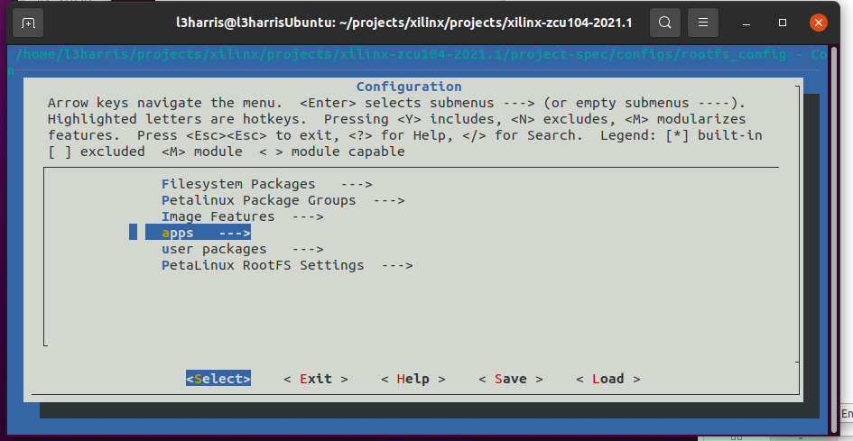

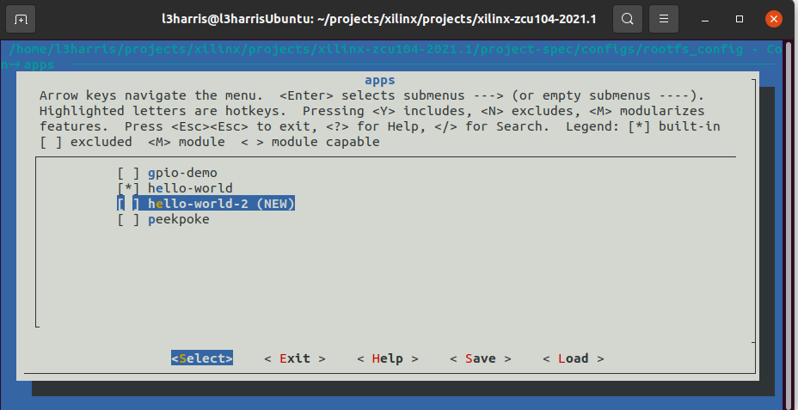
The application itself needs to be built first, which is what the Makefile in the folder with the main source file is for. This Makefile is run with the following command:

petalinux-build -c hello-world-2

Now that the application has been enabled and compiled, rebuild the PetaLinux project as a whole to update the boot image and root filesystem image.

petalinux-build

At the Petalinux prompt, cd to “usr/bin”, the new executable file is located in this folder. Run the new file

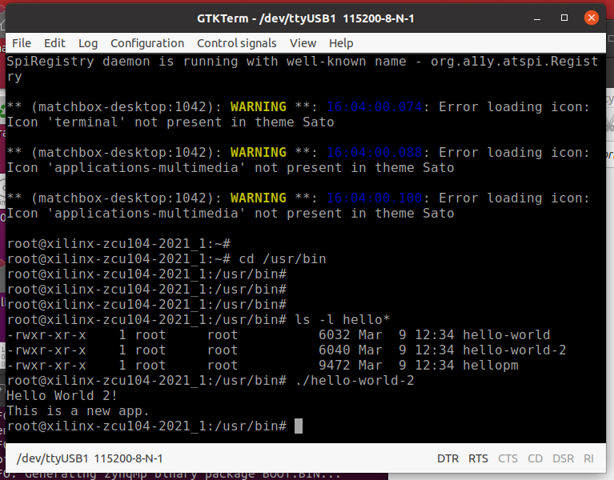

Steps to add a new library (fftw) to Petalinux kernel

https://www.hackster.io/dsp2/fft-acceleration-with-vitis-237412

Note: Assume that the bitbake file is available for the library that you want to add

Update the project-specs/meta-user/conf/user-footfsconfig to add the library
For fftw, add CONFIG_libfftwf
Note: fftw librady are defined as these packages: libfftw, libfftwl, libfftwf

Run petalinux-config -c rootfs, and enable the new library
New library is under user packages

Run petalinux-build

On the target, the new library will be installed in /usr/lib

Useful UIO and Interrupts Links

https://xilinx-wiki.atlassian.net/wiki/spaces/A/pages/18842490/Testing+UIO+with+Interrupt+on+Zynq+Ultrascale

https://www.linkedin.com/pulse/gpio-petalinux-part-1-roy-messinger/
https://www.linkedin.com/pulse/gpio-petalinux-part-2-roy-messinger/
https://www.linkedin.com/pulse/gpio-petalinux-part-3-roy-messinger/

https://www.youtube.com/watch?v=AiChMf4RLkA

https://xilinx-wiki.atlassian.net/wiki/spaces/A/pages/18842191/Linux+GIC+Driver

Screenshots:

petalinux-build
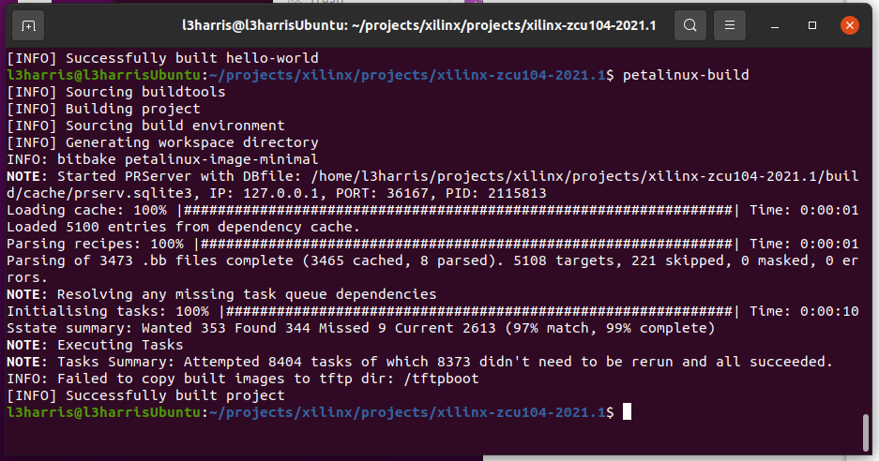
Flash petalinux file system
